**Assignment No. 2**

* ***Aim:***

Selection and use of CT & PT for digital meters.

* ***Apparatus:***

Various Ratings Current Transformer and Potential Transformers.

* ***Objective:***

To explain the concepts and connections of instrument transformers and meters.

* ***Outcome:***

Students will be able to:

1. Select and use instrument transformers.
2. Explain the use of CT and PT.

* ***Theory:***

In this hands-on session, we gained insights into Current Transformers (CTs) and Potential Transformers (PTs). Our introduction began with a thorough explanation of Step-down transformers, designed to decrease alternating current (a.c.) voltage or sources. The primary purpose of a Step-down transformer is to convert high voltage from the primary coil into lower voltage in the secondary coil. Conversely, we also explored Step-up transformers, which elevate the voltage from the primary to the secondary coil by having more turns in the secondary winding compared to the primary winding.

We were then introduced to CTs and PTs. A CT lowers the current signals for measurement purposes, while a PT lowers high voltage values into lower ones. Both are examples of Step-down Transformers.

* **Utilizing Digital Meters with CTs**: Current Transformers play a crucial role in reducing high currents to levels suitable for digital meters. These transformers are integrated into the circuit in series with the load, and their secondary winding is linked to the input terminals of the digital meter.
* **Utilizing Digital Meters with PTs**: Potential Transformers are instrumental in decreasing elevated voltages to levels that align with the capabilities of digital meters. These transformers are incorporated into the circuit in parallel with the load, and their secondary winding is coupled to the input terminals of the digital meter.
* ***Images:***

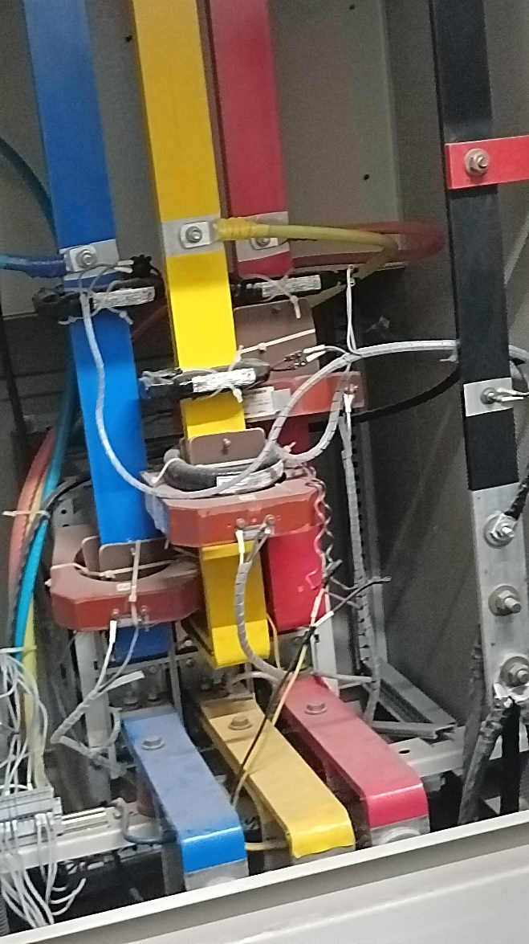

**Figure 1: CTs used at AISSMS Campus main line**

* ***Conclusion:***

Observed CTs at main power house of AISSMS college campus. Used clamp meter and digital meter to examine CT accuracy.